**.NET Assignment - 2**

Github link : <https://github.com/Aishwarya01-github/.NET-Assignments/tree/main/Lab%202>

**Manipulate integral and floating point numbers in C#**

Code :

using System;

namespace Prog1

{

class Program

{

static void Main(string[] args)

{

int a = 18;

int b = 6;

int c = 2;

int d = 3;

double e = 5;

double f = 4;

double g = 2;

decimal h = 1.0M;

decimal i = 3.0M;

Task_1.add(a, b);

Task_1.sub(a, b);

Task_1.mul(a, b);

Task_1.div(a, b);

Task_1.complex(a, b, c);

Task_1.complex2(a, b, c, d);

Task_1.findMinMax();

Task_1.dbAdd(e, f, g);

Task_1.findMinMaxDb();

Task_1.findMinMaxDec();

Task_1.decOp(h, i);

double radius = 2.50;

double area = Math.PI * radius * radius;

Console.WriteLine($"Area : {area}");

}

}

static class Task_1

{

public static void add(int a, int b)

{

Console.Write("Addition : ");

int c = a + b;

Console.WriteLine(c);

}

public static void sub(int a, int b)

{

Console.Write("Subtraction : ");

int d = a - b;

Console.WriteLine(d);

}

public static void mul(int a, int b)

{

Console.Write("Product : ");

int e = a * b;

Console.WriteLine(e);

}

public static void div(int a, int b)

{

Console.Write("Quotient : ");

int f = a / b;

Console.WriteLine(f);

}

public static void complex(int a, int b, int c)

{

Console.Write("Complex : ");

int g = a + b * c;

Console.WriteLine(g);

}

public static void complex2(int a, int b, int c, int d)

{

Console.Write("Complex2 : ");

int e = (a + b) / c;

int f = (a + b) % c;

Console.WriteLine($"quotient : {e}");

Console.WriteLine($"remainder : {f}");

}

public static void findMinMax()

{

Console.Write("FindMinMax : ");

int max = int.MaxValue;

int min = int.MinValue;

Console.WriteLine($"The range of integers is {min} to {max}");

}

public static void dbAdd(double a, double b, double c)

{

Console.Write("DbAdd : ");

double d = (a + b) / c;

Console.WriteLine(d);

}

public static void findMinMaxDb()

{

Console.Write("FindMinMaxDb : ");

double max = double.MaxValue;

double min = double.MinValue;

Console.WriteLine($"The range of double is {min} to {max}");

}

public static void findMinMaxDec()

{

Console.Write("FindMinMaxDec : ");

decimal min = decimal.MinValue;

decimal max = decimal.MaxValue;

Console.WriteLine($"The range of the decimal type is {min} to {max}");

}

public static void decOp(decimal a, decimal b)

{

Console.Write("DecOp : ");

Console.WriteLine(a / b);

}

}

}

Output :

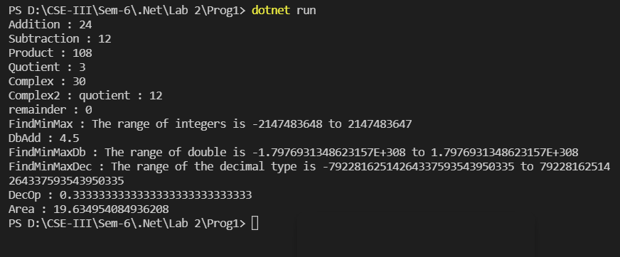

**Branches and Loops**

Code :

using System;

namespace Code_2

{

class Program

{

static void Main(string[] args)

{

int a = 5;

int b = 6;

int c = 4;

if (a + b > 10)

{

Console.WriteLine("This answer is greater than 10. ");

}

else

{

Console.WriteLine("This answer is greater than 10. ");

}

Pro_2.complexIf(a, b, c);

// loops

int counter = 0;

Pro_2.whileLoop(counter);

Pro_2.doWhileLoop(counter);

Pro_2.forLoop();

Pro_2.nestLoops();

Pro_2.challenge1();

}

}

static class Pro_2

{

public static void complexIf(int a, int b, int c)

{

Console.WriteLine("Output of complexIf...");

if ((a + b + c > 10) && (a == b))

{

Console.WriteLine("The answer is greater than 10");

Console.WriteLine("And the first number is equal to the second");

}

else

{

Console.WriteLine("The answer is not greater than 10");

Console.WriteLine("Or the first number is not equal to the second");

}

if ((a + b + c > 10) || (a == b))

{

Console.WriteLine("The answer is greater than 10");

Console.WriteLine("And the first number is equal to the second");

}

else

{

Console.WriteLine("The answer is not greater than 10");

Console.WriteLine("Or the first number is not equal to the second");

}

}

public static void whileLoop(int counter)

{

Console.WriteLine("Output of whileLoop...");

while (counter < 5)

{

Console.WriteLine($"Hello World! USING While Loop The counter is {counter}");

counter++;

}

}

public static void doWhileLoop(int counter)

{

Console.WriteLine("Output of dowWhileLoop...");

do

{

Console.WriteLine($"Hello World! USING Do While Loop The counter is {counter}");

counter++;

} while (counter < 5);

}

public static void forLoop()

{

Console.WriteLine("Output of forLoop...");

for (int counter = 0; counter < 10; counter++)

{

Console.WriteLine($"Hello World! USING For Loop The counter is {counter}");

}

}

public static void nestLoops()

{

Console.WriteLine("Output of nestLoops...");

for (int row = 1; row < 11; row++)

{

for (char column = 'a'; column < 'k'; column++)

{

Console.WriteLine($"The cell is ({row}, {column})");

}

}

}

public static void challenge1()

{

Console.WriteLine("Output of challenge1...");

int sum = 0;

for (int number = 1; number <= 20; number++)

{

if (number % 3 == 0)

{

sum = sum + number;

}

}

Console.WriteLine($"The sum is {sum}");

}

}

}

Output : 